Princess Royal Spinal Cord Injury Centre Therapy Guidance for the Management of Spinal Cord Injury Patients at Referring Hospitals

Appropriate management of spinal cord injury patients can prevent secondary complications and optimise functional outcome. For those clinicians working outside of specialist centres this guidance should be used in conjunction with advice from the Princess Royal Spinal Cord Injury Centre (PRSCIC), Sheffield as well as the PRSCIC Initial Care Management for Patients with Acute Spinal Cord Injury booklet.
Having sustained a spinal cord injury a number of neurological and physiological changes take place. Patients may be on bed rest either because of associated injuries or as part of the definitive management of the skeletal injury. Acute management should aim to deal with the consequences of trauma, prevent secondary complications, preserve neurology and promote functional recovery.
These guidelines include the following sections:
- Assessment
- Respiratory considerations
- Positioning
- Maintaining range of movement
- Oedema management
- Spasticity management
- Orthoses/splinting
- Mobilising and wheelchair provision

The therapy contact details for the PRSCIC are:
- Occupational Therapy: 0114 2715666
- Physiotherapy: 0114 2715673

Assessment
Initial medical management should focus on assessment to clarify the following:
- Past medical history
- Medical stability
- Spinal stability
- Restrictions on movement
- Associated injuries
In accordance with the protocol for The Initial Management of Adults with Spinal Cord Injury (2012) a detailed neurological assessment should be carried out by a member of the medical team which should include the American Spinal Injury Association (ASIA) Impairment Scale (AIS) (https://asia-spinalinjury.org/learning/). Spinal stability and associated injuries will determine in what position assessments and treatments can be carried out. Advice from treating Consultants should be sought if there is any doubt.

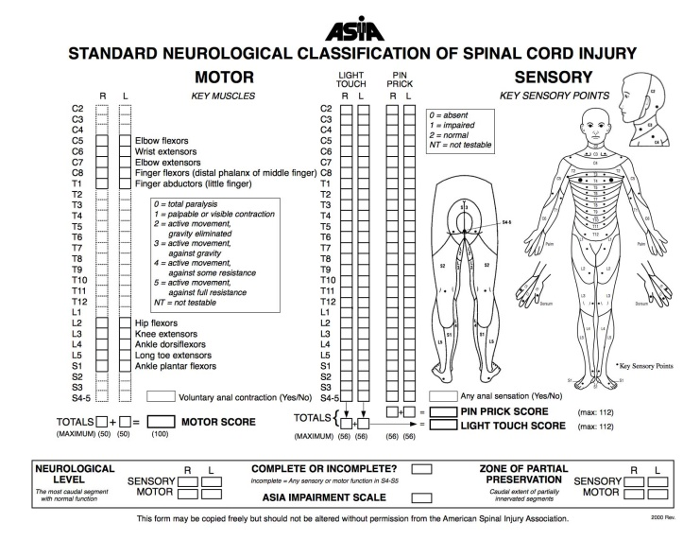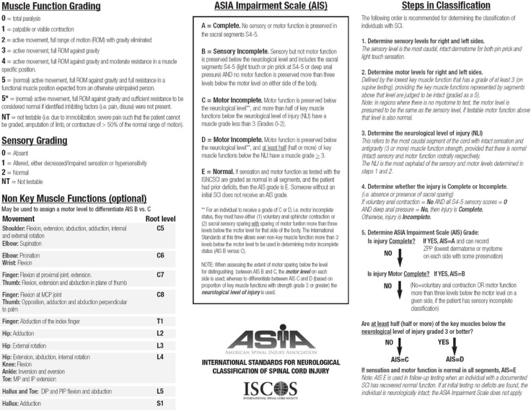

Respiratory Considerations
The level of spinal cord injury will determine a patient’s respiratory function. Patients who have paralysis above T6 will not have innervation of the abdominal muscles. This will mean that they are unable to perform a powerful cough on their own. This can lead to sputum retention. Any patient with decreased cough power may need an assisted cough. Patients with a tracheostomy for suction may still require an assisted cough as if the patient does not have a powerful cough only secretions at the top of the suction catheter ie the carina will be cleared.
Methods of assisted cough:
There are many techniques that can be used to perform an assisted cough. Clear verbal direction and co-ordination between the person helping and the patient is essential for any technique to be successful. Which technique you use will depend on patient presentation (i.e whether you can push on the abdomen or not), patient positioning and personal preference.

Direction of pushing:
If applying an abdominal push to assist the cough the movement should be inwards and upwards as illustrated below.

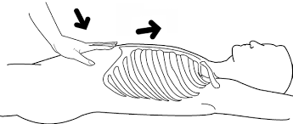

The movement should be swift, fluid and in one movement. Remember you are trying to replicate a cough which has a very powerful explosive nature and produces fast respiratory flows.

Method 1.

One hand is placed below the rib cage but above the stomach whilst the other arm stabilises the rib cage, as the patient attempts to cough the therapist simultaneously pushes inwards and upwards with the lower arm whilst stabilising with the upper arm. This technique can also be performed by two people, one on each side of the bed.

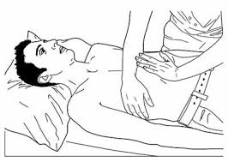
Picture from: Teaching Manually Assisted Cough to Caregivers of Children with Neuromuscular Disease, Kan et al (2018)

Method 2.

Some people are unable to tolerate pushing on the diaphragm, so compression on the sides of the ribcage can be used in an inward and upward direction.

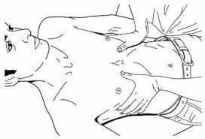
Picture from: Teaching Manually Assisted Cough to Caregivers of Children with Neuromuscular Disease, Kan et al (2018)

An assisted cough can be judged as being effective if:

- The patient expresses relief / clearance of immediate secretions
- The cough sounds strong in comparison to an unassisted cough
- The patient expectorates orally or swallows secretions.
- Secretions can be cleared with shallow tracheal suctioning only.
- Overall comfort and effectiveness of the technique, from the patients perspective

Considerations when performing an assisted cough:
- Sensation - will an assisted cough be painful?
- PEG feed - think about your hand position.
- Co-ordination between patient and therapist - you need to be pushing at the exact moment that they start to cough.
- Contraindications: paralytic ileus, abdominal aneurysm, severe osteoporosis, abdominal injury/internal bleeding, pregnancy.

In addition to a manual assisted cough or if a manual assisted cough is contraindicated a mechanical assisted cough machine such as the Respironics E70 or Nippy Clearway maybe considered to aid chest expansion and clearance. At the PRSIC patients who are receiving prophylactic mechanical cough assist treatment will receive it once a day and if it is used for active treatment the frequency will depend on clinical need.

For information regarding ventilator weaning of spinal cord injury patients please see the below link:
http://risci.org.uk/weaning-guidelines-for-spinal-cord-injured-patients-in-critical-care-units/

Positioning
Patients with an acute spinal cord injury are dependent on others while on bed rest to maintain their skin integrity and to ensure their limbs are positioned to maintain joint alignment and soft tissue length thereby preventing subluxation, impingement and contractures. The below pictures as well as further information regarding positioning can be found in ‘Moving and handling patients with actual or suspected spinal cord injury’ at the following link. https://www.mascip.co.uk/best-practice/mascip-best-practice/

We do not routinely use pressure relieving ankle foot orthoses (PRAFO) and instead use pillows to maintain ankle range as per picture 7 in the postural alignment pictures. We would consider the use of PRAFOs with patients with significantly increased tone.
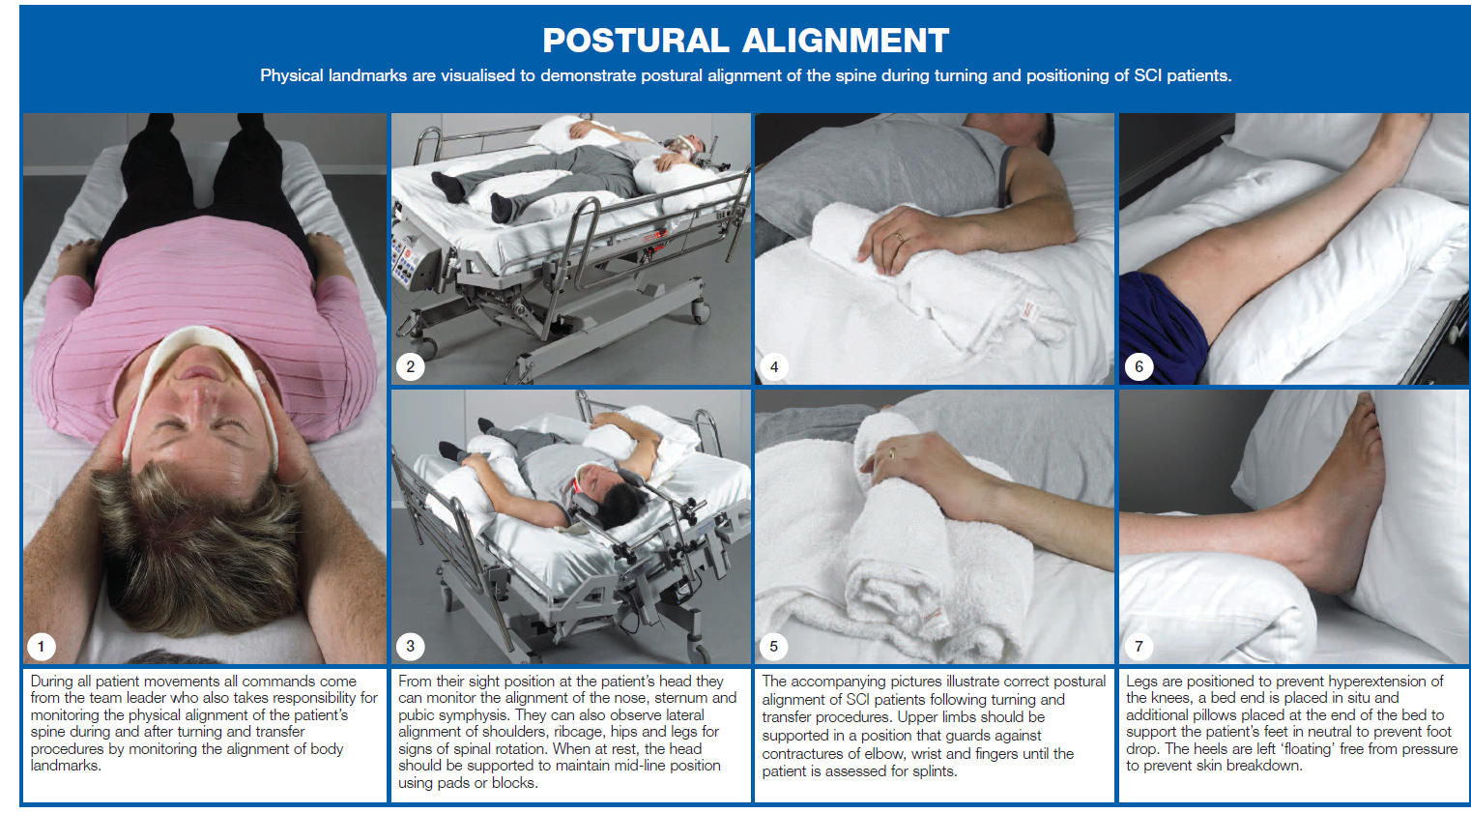

Maintaining Range of Movement
Passive range of movement of muscles/joints affected by the spinal cord injury should be carried out as a priority from the day of admission with all joints put through as complete a range of passive motion as pre-morbid presentation, spinal stability, associated injuries, pain and oedema allows.
Particular attention needs to be paid to individuals with a C5 level of injury as they are prone to elbow flexion and forearm supination contracture due to a pattern of innervation of unopposed biceps and supinators. While the patient is on bed rest, the tendency for a contracture is increased as once their elbow is flexed, whether actively or by spasm, the patient may be unable to extend it without assistance. The prevention of contracture and the maintenance of a full elbow, wrist and forearm range of motion is an essential component of rehabilitation for these patients as they need full elbow extension, wrist extension, forearm supination and pronation to reach the optimal level of functional ability e.g. using a self-propelling manual chair.
The amount of passive movement exercises which are required is not evidenced, however less than 10 repetitions of each movement at a joint each day is unlikely to be therapeutic. It is recommended that passive range of movement is carried out in conjunction with positioning and prolonged stretch and should be conducted at least once a day unless there is a clinical indication for them to be performed more frequently such as increased tone or pain.
Active range of movement is encouraged with the use of active/assisted facilitation of movement initially through de-weighting either by a practitioner or use of gantry systems (e.g. OB help arm, mobile arm support systems) as available. The use of small weights and resistance can be considered, as long as the movement does not impact on spinal stability, overall medical management or the ability to recruit good patterns of movement. The below leaflets provide further details on passive movements and can be found at www.sth.nhs.uk/patients/patient-information/find-a-leaflet/search-for-a-leaflet and searching for passive movements.

Oedema Management
Dependent oedema of the hands and arms is almost universal in tetraplegic patients. The dependent position of the hand further increases the likelihood of swelling. Early prevention and management of oedema is critical.
Immediate input is required to prevent and manage the oedema including:
- Elevation of the forearms and hands on pillows as part of the positioning regime
- Lymphatic massage to facilitate drainage
- Application of prefabricated compression gloves and sleeves or use of oedema taping
- Passive movement of all joints of the upper limb within available range, or within limits of pain
- Active movement of all joints available to the individual within available range, or within limits of pain
- Orthoses/splinting

Spasticity Management
It is important that spasticity be adequately controlled if it is interfering with position and posture or causing pain. A tiered approach should be taken with management of any exacerbating factors and physical measures should be adopted before pharmacological or interventional measures. Physical measures may include passive stretches, positioning, prolonged stretch via splinting/orthoses, casting, serial casting or functional electrical stimulation. Once physical measures have been fully explored the use of anti-spasmodic pharmacological management should be considered.
Orthoses and Splinting
Orthoses (e.g. splints) can reduce complications by protecting joint structures where muscular support has been lost or weakened and for the following:
- Maintain joint alignment
- Prevent/minimise contractures
- Prevent overstretching
- Promote venous return
- Provide joint stability and placement for function
- Maintain cosmesis

General recommendations for spinal injury splinting:
- C1 – C4 : long resting splints
- C5 : long resting splints, elbow ranger braces, TAP splints
- C6 – T1: short resting splints

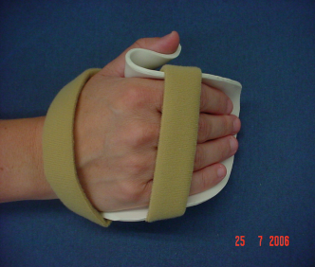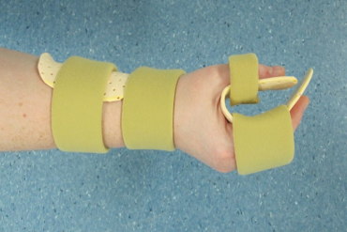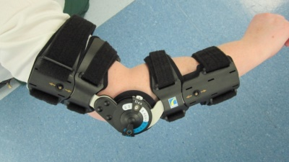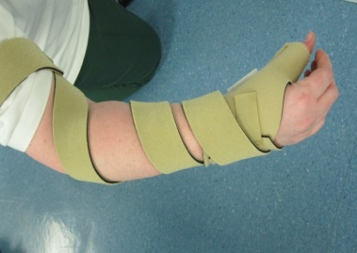
Long resting splint
Short resting splint
Elbow ranger brace
TAP splint

Mobilising and Wheelchair Provision

There should be agreement between the local area Consultant and the Spinal Cord Injury Consultant that a patient can mobilise and this will be dependent on spinal column stability as well as skin integrity, there may be the need for a cervical collar or thoracic lumbar sacral orthosis (TLSO). The PRSIC Initial Care Management for Patients with Acute Spinal Cord Injury advises bed rest for at least the first 2 weeks post injury.

Once a patient can mobilise they should be gradually sat up in bed to allow their blood pressure to adjust, it can take a couple of days for them to be able to sit upright without feeling dizzy. They should then be transferred using a hoist into a wheelchair for an increasing amount of time each day. Their skin integrity should be closely monitored when they have started sitting up in bed and when they have started getting out into the wheelchair.

Appropriate wheelchair seating is an integral aspect of the overall management of people with a spinal cord injury. It is unlikely that referring hospitals will have access to a wide variety of wheelchairs and cushions, however the below are points to consider with regards to posture and seating.

Good seating:
- Provides comfort and stability
- Allows someone to engage easily in activities of daily living (ADL)
- Reduces potential for skin breakdown
- Maximise function and independence

Wheelchair width:
The wheelchair should have about 1 inch breadth between each side of the hips and arm rests. A wheelchair with the correct width helps to maintain the pelvis in the right position and provides some trunk support and reduces the potential for skin breakdown.
Foot rest position:
The footrest position should be adjusted so that the hips and knees are approximately at 90° flexion and the thighs are horizontal or slightly raised. This position assists in distributing pressure over the entire area of the buttocks and the thighs.

Tilt in Space Wheelchairs:
Tilt in space wheelchairs provide more support for higher level injuries; the tilt function can be used for patients with ↓ BP, they allow for improved breathing and visual field if a patient is kyphotic and they help maintain good positioning and pressure distribution. The tilt function should be used instead of recline as reclining a backrest can cause a patient to slide forward in their seat and alter the pressure distribution.

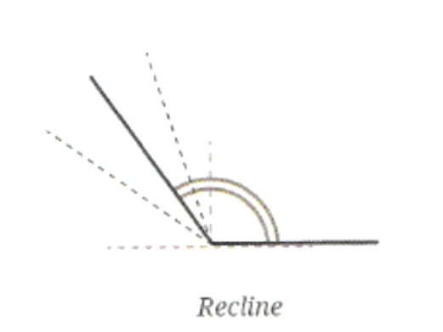
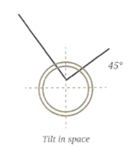
Considerations when choosing a cushion:
- Risk factors (age, level of spinal cord injury, ASIA score and function)
- Skin integrity
- Posture, balance and comfort
- Effective distribution of body weight

Pressure relieving:
This should be performed for 2 minutes every hour. Cushions are not a substitute for pressure relieving.
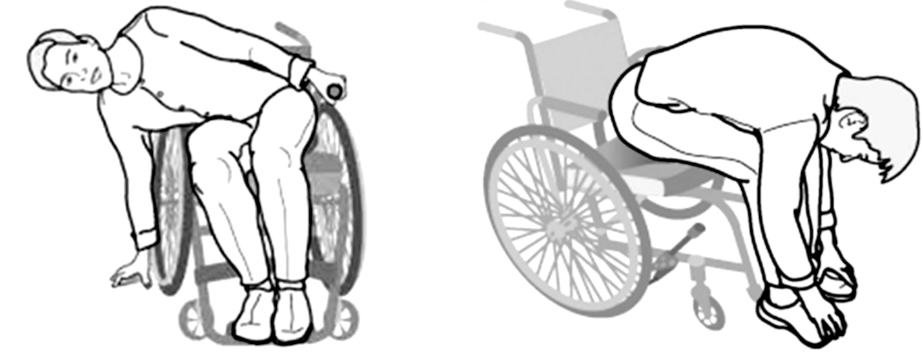

(Pressure relieving option positions, taken from Smit et al (2013) Gluteal blood flow and oxygenation during electrical stimulation induced muscle activation versus pressure relief movements in wheelchair users with spinal cord injury). For both the above positions ensure the wheelchair castors are facing forwards as this will make the wheelchair more stable.
For more information regarding seating the below patient information booklets can be found at www.sth.nhs.uk/patients/patient-information/find-a-leaflet/search-for-a-leaflet and searching for wheelchair.

Useful resources
Aspire www.aspire.org.uk
Back-Up www.backuptrust.org.uk
Multidisciplinary Association for Spinal Cord Injury Professionals (MASCIP) www.mascip.co.uk
Spinal Injuries Association (SIA) www.spinal.co.uk
Respiratory Information for Spinal Cord Injury (RISCI) www.risci.org.uk

